Tab 1

PROJECT PROPOSAL
Team Charter for QUALITY SQUAD
Purpose (What is the purpose of being a team?):  The purpose of this team is to learn more about analyzing and visualizing data by developing our skill sets together as a team. | Goals (What are measurable and specific goals that support and link to the purpose?  - Work together in a way that accentuates our strengths  - Ensure that each team member is contributing (divide tasks, rotation of roles)  - By the completion of this project, each team member develops their technical and leadership proficiency and skillsets.
Team Member Roles and Responsibilities
Name & email | Role | Task
Christopher Chan (christopher.chan.093@gmail.com) | Technical Lead | - Leads meeting progression.  - Ensures technical pieces are reviewed by the team
Eleni Asfaw  eleniasrat1990@gmail.com | Process Manager | - Tracks deadlines, milestones, and rotations  - Manages the task list  - Ensures submissions are uploaded to Brightspace
Paolo Pagnozzi  (pjpagnozzi@gmail.com) | Communication manager #1 | - Schedules meetings and sends reminders  - Distributes updates to the team
Zhenfang Liu  liuzhenfang689@gmail.com | Communication manager #2 | - Records and organizes meeting notes (Google Docs)
Team Rules
Ground Rules (see examples below - but create your own rules!):  - Everyone should be on time and come prepared to each meeting with one idea/relevant question to move the process forward  - Everyone should communicate with other team members with open-mindedness  - Work responsibilities must be fulfilled on time. |  | Communication Protocol:  - Primary mode of communication: iMessage (group chat) and Zoom  - Frequency of communication:  As needed, with a once-a-week check-in – Fridays at 9 PM  - Response time:  no longer than a day  Primary communication coordinator:  Paolo Pagnozzi

Dataset Description
Our team uses the dataset from various City Open Datasets, which is public data published by City agencies and other partners, to compare New York City’s quality of life indicators across 10 U.S. cities that we selected, including New York City, Dallas, San Francisco, Phoenix, Boston, Washington D.C., Los Angeles, Seattle, Miami, and Chicago. The datasets contain key information on the metric that we focus on. Education data reflect school directory, location, graduation rate, test performance, etc. Housing data from NYC Open Dataset includes information on housing consumption and utilities costs, which reflect residents’ living affordability levels across other cities we selected. Recreation data covers the availability of parks, libraries, pools, etc. Health data provides community health surveys and health insurance enrollment. And transportation data capture commute ways across the city. Similar open data from other cities will be collected for comparison.
Starting Question:
- How does NYC’s quality of life compare to the other selected cities?
10 Selected Cities: NYC, Dallas, San Francisco, Phoenix, Boston, D.C., Los Angeles, Seattle, Miami, Chicago.
Quality of life metrics for the project:
- Education
- Health
- Income vs home prices
- Access to Recreation - # of community centers, parks, libraries
- Commute time
Questions to explore with this project?
- How does the attainment of higher education compare between the different US cities?
- How does the graduation rate compare between the different cities?
- How does the average commute time compare between NYC and the different cities?
- How does the number of residents with health insurance compare between NYC and the selected cities?
- How do the median income and house prices (mortgage and rental) compare between NYC and the selected cities?
- How does access to recreation(# of community centers, parks, libraries, museums, etc) compare between NYC and the selected cities?

PROGRESS REPORT
Changes to Initial Questions and Methodology
After submitting our project proposal with our initial research questions a month ago, we took a closer look at the datasets available through various Open City data portals. We found that most of the cities we originally selected did not provide datasets that were aligned in terms of reporting years, data collection, data presentation, or data completeness. As a result, we narrowed our scope and selected cities whose datasets were more comparable to NYC, ultimately choosing Boston, NYC, and San Francisco.
Despite the availability of a substantial amount of public data from the three cities, obtaining clean, reliable datasets suitable for direct comparison on our questions still presented its own challenges. After careful evaluation, we decided to rely primarily on DataUSA.io, which aggregates standardized datasets sourced from the U.S. Census (ACS), BLS, BEA, and IPEDS. These sources allowed us to maintain data alignment on most of our research questions.
For our question regarding housing costs (rent and mortgage), we selected the Zillow database and its indices as they provide a convenient and comparable dataset across cities over time.
Unfortunately, we decided to remove our sixth research question (How does access to recreation (e.g., number of community centers, parks, libraries, museums) compare between NYC and the selected cities?) due to the limited availability of standardized data and time constraints.

Completed and Remaining Tasks
We have completed the quality assessment of our datasets and have verified that they are aligned and suitable for direct comparison across the three selected cities. We have also divided the research questions among team members and created a dedicated folder and Jupyter notebook for each question in our shared Google Drive. This setup enables the team members to work independently on their assigned tasks while facilitating collaboration and feedback.
Over the next three to four weeks, our focus will be on further analyzing these datasets and creating data visualizations, applying the techniques and concepts we are currently learning in class.
Changes to Current Roles
Zhenfang and Paolo will switch roles. Other changes to current roles will be discussed if needed.

Initial Data Exploration and Analysis
Our exploratory data analysis examined four major quality-of-life indicators across New York City, Boston, and San Francisco. Each team member analyzed metrics included in our initial questions: income and housing, commuting patterns, educational attainment, and health insurance coverage. Below is a detailed summary
How does the attainment of higher education compare between the different US cities?
Dataset Overview
For this part of the project, we focused on the NYC educational attainment data from the ACS DP02 2008–2012 file (nyc_EDUCATIONAL ATTAINMENT08-12.xlsx). The dataset is huge — 174 rows and 781 columns — because it breaks out social and demographic characteristics for every Neighborhood Tabulation Area (NTA) in NYC. The rows represent different categories (like population 25+, high school graduate or higher, bachelor’s degree, etc.), while the columns contain each neighborhood’s estimates, percentages, and margins of error.
Metrics Selected for Analysis
To keep the analysis consistent across cities (NYC, Boston, and San Francisco), we focused on the three educational attainment indicators that are most commonly compared:
- High school graduate or higher (25+)
- Bachelor’s degree or higher (25+)
- Graduate or professional degree (25+)
These will serve as the main comparison points once we bring in the Boston and SF datasets. Data Structure and Variables
Each neighborhood in NYC has the same four variables for each indicator: estimate, estimate MOE, percent, and percent MOE.
Because the dataset is vast, the percent columns are the most useful for comparing cities. They let us compare relative educational attainment without the differences in neighborhood population size getting in the way.
Data Quality Observations
- The dataset looks complete. We didn’t come across missing values in the rows related to educational attainment.
- The naming of neighborhoods is consistent across all columns, which makes filtering and restructuring easier.
- Although the dataset is extensive, it’s well-organized. Converting it from a wide format to a long format later will make plotting and comparisons much easier.
Initial Findings (NYC):
A few clear patterns are expected to show up upon further analysis:
- There’s a lot of variation across NYC neighborhoods in terms of bachelor’s degree and graduate degree attainment.
- Some areas are clearly much more highly educated than others.
- High school attainment is consistently high almost everywhere.
The biggest differences appear to be in BA+ and graduate-level attainment, which is where the educational divide across neighborhoods is more pronounced.
These early observations will help frame the comparisons once we incorporate the Boston and San Francisco datasets.
Next Steps
- Extract only the rows related to educational attainment from the NYC DP02 dataset.
- Gather the equivalent tables for Boston and San Francisco.
- Reshape the dataset to long format for easier plotting across cities.
- Calculate summary statistics for the three key indicators (HS+, BA+, Graduate+).
- Make comparison visuals (likely bar charts or grouped bars) for the final report.
2. How does the average commute time compare between NYC and the different cities?
For this question in the project proposal, we have identified the pertinent high-quality datasets for three cities: New York City, Boston, and San Francisco. These datasets align in terms of measured values, reference years, and error margins, making them suitable for direct comparison.
During our initial analysis, we realized that fully addressing this question requires acknowledging that residents in each city rely on different modes of transportation. Because the percentage of residents who rely on the different modes of transportation varies across cities, comparing average commute time alone would not provide a complete picture. For this reason, we expanded our data exploration to include the share of residents using different modes of transportation in each city.
Our goal is to present the average commute time while also accounting for variation in transportation modes, thereby offering a more comprehensive understanding of how the quality of daily commuting experiences differ across cities. However, it is important to note that we are unable to control for differences in total miles traveled per commute due to the lack of consistent, publicly available data.
Additionally, in the post-pandemic era, a substantial portion of residents work from home, resulting in shares of residents who effectively have no commute and need to be accounted for in our data analysis. Our initial exploration of the percentage of residents who rely on public transit and the percentage who work from home is summarized in the bar chart shown below.

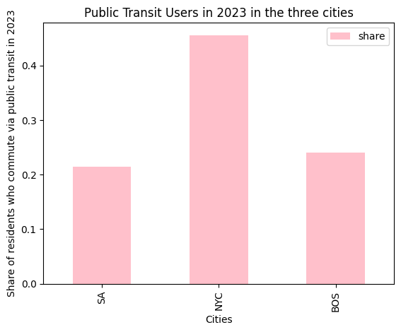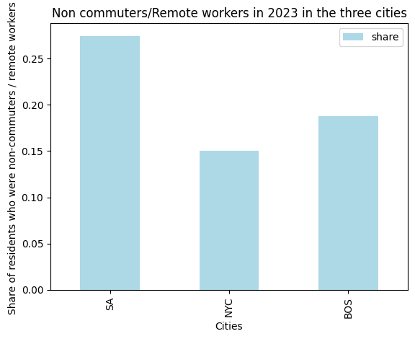

Our plan moving forward is to incorporate more complex grouped bar charts to visually compare both the distribution of transportation modes and the average commute times across the three cities. These visualizations will allow us to present side-by-side comparisons and highlight differences in commuting patterns and overall travel time.

3. How does the number of residents with health insurance compare between NYC and the selected cities?
Similarly, for this question in the project proposal, we have also identified datasets that align across key attributes(measured variables, reference years, and error margins), allowing for a valid and direct comparison of insured populations across the three cities. This alignment enhances the methodological integrity of our analysis, ensuring that any observed differences reflect actual variations in insurance coverage rather than inconsistencies in data collection or reporting practices. The resulting comparison will enable us to identify patterns, disparities, or trends in health insurance coverage between NYC and our selected peer cities.
Our goal is to compare the number of residents with health insurance across cities while also considering differences in the types of insurance coverage available and to provide a more comprehensive understanding of how access to healthcare varies between urban populations. It is important to note that we are unable to control for underlying factors such as income distribution, immigration status, or employer benefits policies, as consistent and comparable data on these variables are not publicly available across all cities.
Our initial exploration of the percentage of residents who have health insurance in each respective city is summarized in the bar chart shown below.

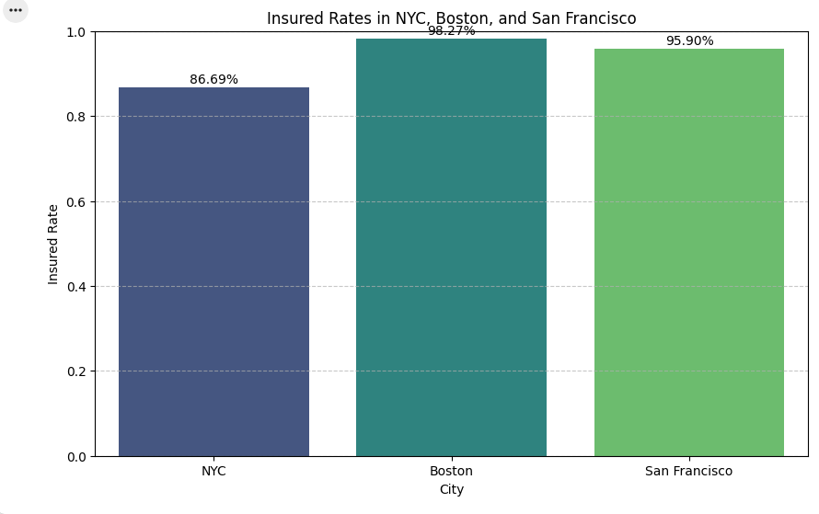

Further analysis could explore the underlying factors contributing to these disparities, such as city-specific healthcare policies, socio-economic demographics, and employment characteristics.

4. How do the median income and house prices (mortgage and rental) compare between NYC and the selected cities?
Dataset Overview
For this question in our project, we used ACS data (Race = Total, Year = 2023) to compute the median household income and Zillow’s housing price data.
Initial Dataset Exploration and Findings
Using ACS data (Race = Total, Year = 2023), we computed the median household income for New York, San Francisco, and Boston. San Francisco has the highest median income at $143,531, but it also has the most expensive housing prices at $1,100,417.44. Boston’s median household income is lower, at about $92,560, but it is the most balanced city in this comparison, with a housing price of $656,954.83. New York City has the lowest median income among the three, at about $ 82,037.50, but its housing price is still high at $634,912.43. Based on the results for NYC, Boston, and San Francisco, there is a clear gap between median income and typical housing prices in all three cities. In each case, housing prices are much higher than what a median-income household earns in one year. The high cost of housing relative to income remains a significant issue in all three cities.
It is important to note that the housing data used for the analysis above is drawn from Zillow’s Home Value Index for the “all homes”. This metric reflects the typical value of homes located in the middle of the market in the given region.
Next Steps
- Identifying variables that could impact our findings
- Look for further findings in the historical housing and income data
- Incorporate and compare rental prices amongst the three cities
- Make comparison visuals (likely bar charts or grouped bars) for the final report.
PROJECT REPORT
Introduction

Urban living conditions vary widely across major U.S. cities, shaped by factors such as education, commute time, healthcare, income, and housing affordability. As New York City, Boston, and San Francisco continue to attract diverse populations and high-skill workers, understanding how these cities differ in overall quality of life has become increasingly important. This project aims to provide a data-driven comparison of these three metropolitan areas using publicly available datasets from dataUSA, American Community Survey (ACS), Zillow housing data, and other census sources.

Our analysis focuses on four key indicators that reflect everyday living conditions: higher-education attainment, average commute time, health insurance coverage, and comparison of median income and housing price. Each team member examined one of these indicators, and together they form a cohesive framework for evaluating quality of life across the selected three cities.

Using Python for data importing, cleaning, transformation, and visualization, we combined multiple datasets. Each selected dataset contains thousands of records that help explain the strengths and constraints of each city. Our goal is not only to compare the three cities across these metrics, but also to build a clear narrative that highlights how these factors interact to influence residents’ overall lives.

This report presents our findings, visualizations, and interpretations, offering a data-driven perspective on how quality of life differs among New York City, Boston, and San Francisco.

Challenges Encountered During Development

One of the biggest challenges we faced during this project was determining an appropriate research scope and identifying reliable datasets to support our analysis. Our initial plan was to compare 10 different cities across 6 indicators. Professor Javaly pointed out that the amount of data required to support a broad study was beyond what we could reasonably collect and process. After confirming with the professor, we decided to narrow the project to three cities and four key indicators, which made the analysis more manageable.

The data collection process itself also presented significant difficulties. For each indicator, we needed to ensure that the datasets were not only from valid sources but also that the internal contents were sufficiently detailed to support meaningful analysis. Many of the datasets we initially found lacked specific variables. We had to repeatedly confirm whether a dataset was usable before incorporating it into our workflow.
Overall, the most challenging part of the project was not the analysis itself, but rather finding, validating, and preparing the right data. Once the data issues were resolved and the scope was properly refined, the Python analysis and visualization became much more straightforward.

Description of Data Preparation
To prepare our data, we used the Jupyter Notebook Colab environment. The preparation of data for each question answered in this project is as follows:
- Means of Commuting Dataset: CSV files were loaded from our shared Google Drive folder. The Jupyter notebook reads each city’s file, appends them into a single dataframe, and adds columns identifying both the source file and the city to enable cross-city comparisons. After verifying structure through shape checks and random samples, the notebook computes share variables to express each commuting category as a proportion of the total for each city.
- Average Commuted Time Dataset: A similar process is used for the average commute-time data: each city’s file is read in, shapes and samples are inspected for consistency, and the datasets are then concatenated and de-duplicated to create a unified table of travel-time categories by year and city.
- Health Insurance Coverage Comparison: For the health insurance section, the code combines Kaiser coverage-by-age data across years and cities, then filters to the specific years of interest (2020-2023) to focus on recent trends. It engineers an “Insured Share” variable by subtracting the uninsured percentage from 100, producing parallel columns for uninsured and insured shares by age group and city. Sample rows are displayed after each key step (combining, filtering, and creating new columns) to validate that the transformations worked as intended and that the resulting tables have the expected structure and values.
- Housing Price vs. Median Income Comparison: Data preparation for the housing price vs. median income analysis included verifying that the different datasets were properly aligned, creating a dataframe that identified each city’s median income, and cleaning the Zillow data to produce a usable housing-price dataframe. After these steps, the income and housing-cost information were merged into a single combined dataframe for comparison.
- Education Attainment Comparison: Data preparation for educational attainment involved filtering the dataset to retain only relevant rows and columns, cleaning the data by dropping missing values to prevent errors, and calculating a population-weighted average for New York City. This weighting ensures that the city’s diverse boroughs are appropriately represented, allowing for a fair comparison with Boston and San Francisco.

Answer to Initial Questions

Overall, our results show that New York, Boston, and San Francisco all have high insurance coverage and relatively high incomes, but they differ markedly in commuting patterns, housing cost pressures, and the level of educational attainment of their populations.

In 2023, New York City stands out in transit use: about 46% of commuters relied on public transportation, far exceeding Boston (~24%) and San Francisco (~21%). Driving alone was most common in Boston (about 34%), followed by San Francisco (~29%) and New York (~22%). San Francisco had the highest share of people working from home (~27%, compared with ~19% in Boston and ~15% in New York), while Boston held a slight lead in walking and cycling rates.

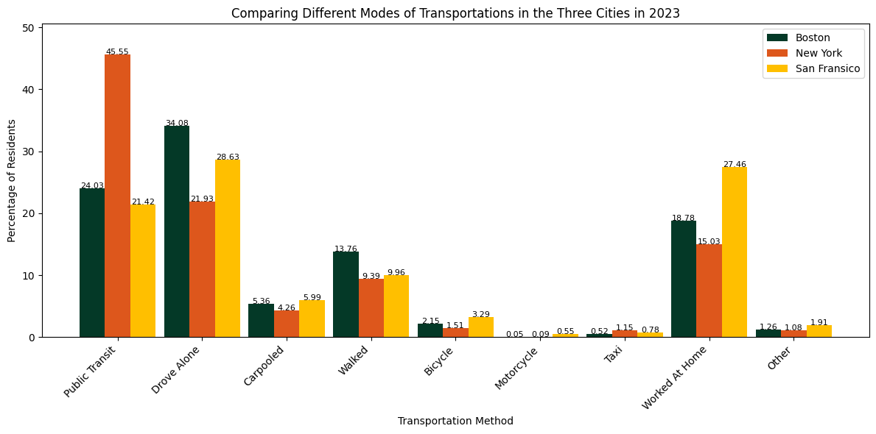

A larger share of residents in these cities have commutes longer than 30 minutes compared with the U.S. average. In New York City, the average commute for most residents exceeds 35 minutes, with about 18% commuting 60–89 minutes daily. In Boston and San Francisco, the distribution of commute times is broadly similar to each other. It is important to note that New York City is geographically much larger (over 300 square miles) compared with Boston (89.6 square miles) and San Francisco (46.89 square miles), which contributes to longer travel times. 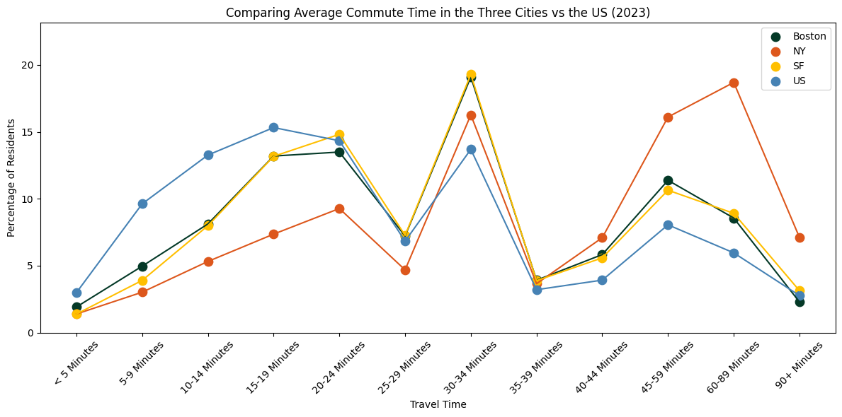

The cleaned Boston survey shows extremely high insurance coverage: roughly 98% of the total population is insured, with children and older adults essentially at or near full coverage. The NYC and San Francisco datasets (NYC EH Portal and CityHealthDash) similarly show insured rates in the mid- to high-90% range across age groups, indicating that all three cities maintain a strong coverage floor. Differences appear more by age group and coverage type (public vs. private) than by the city itself.

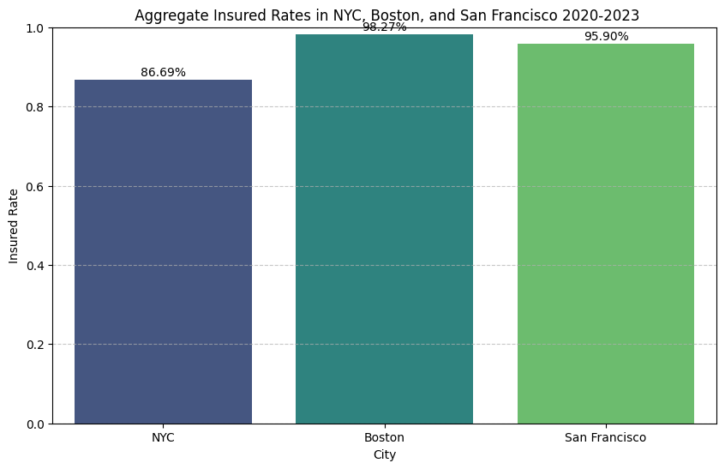
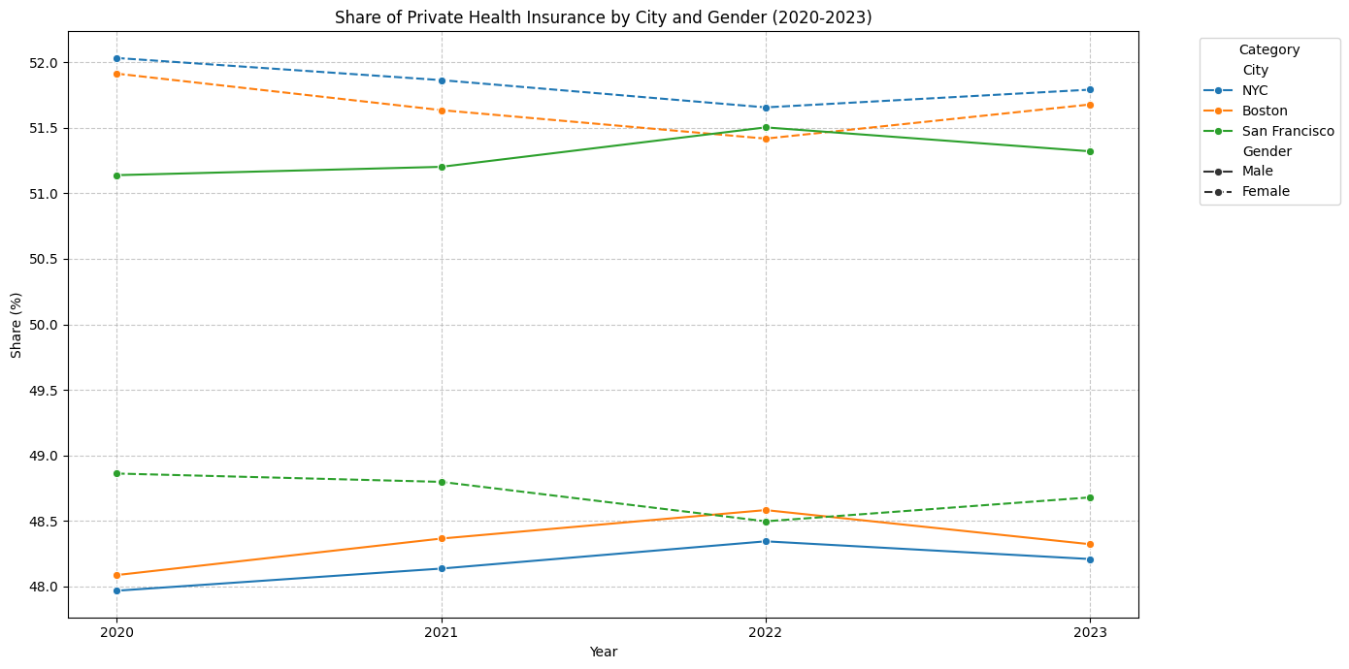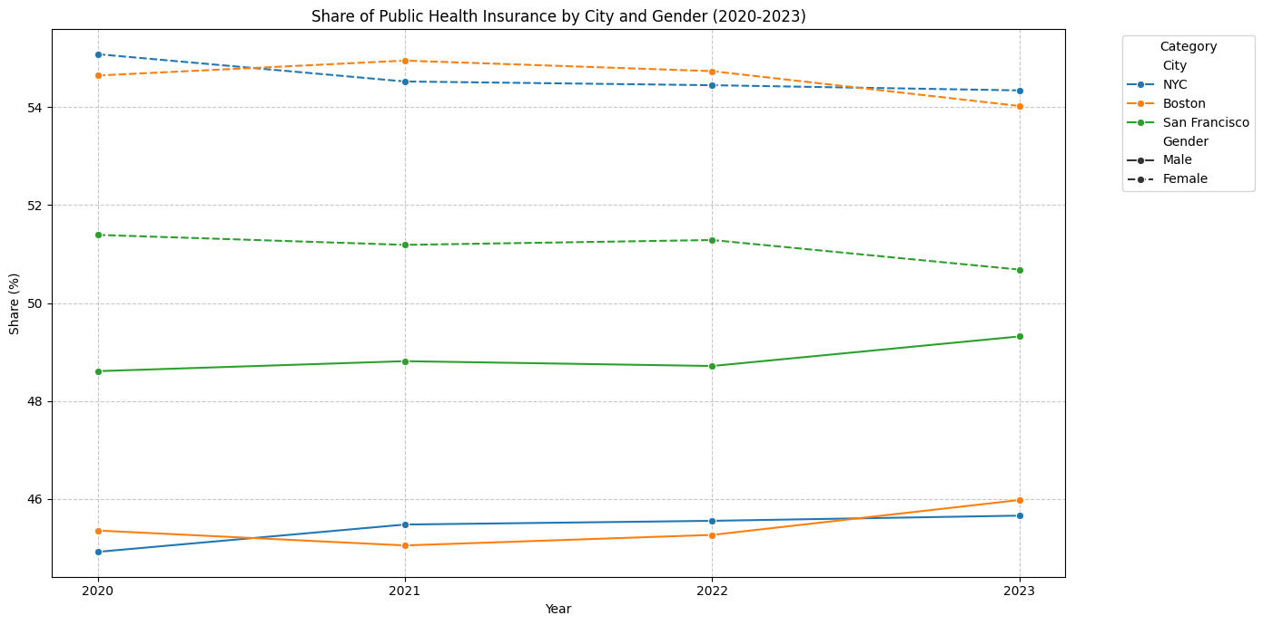
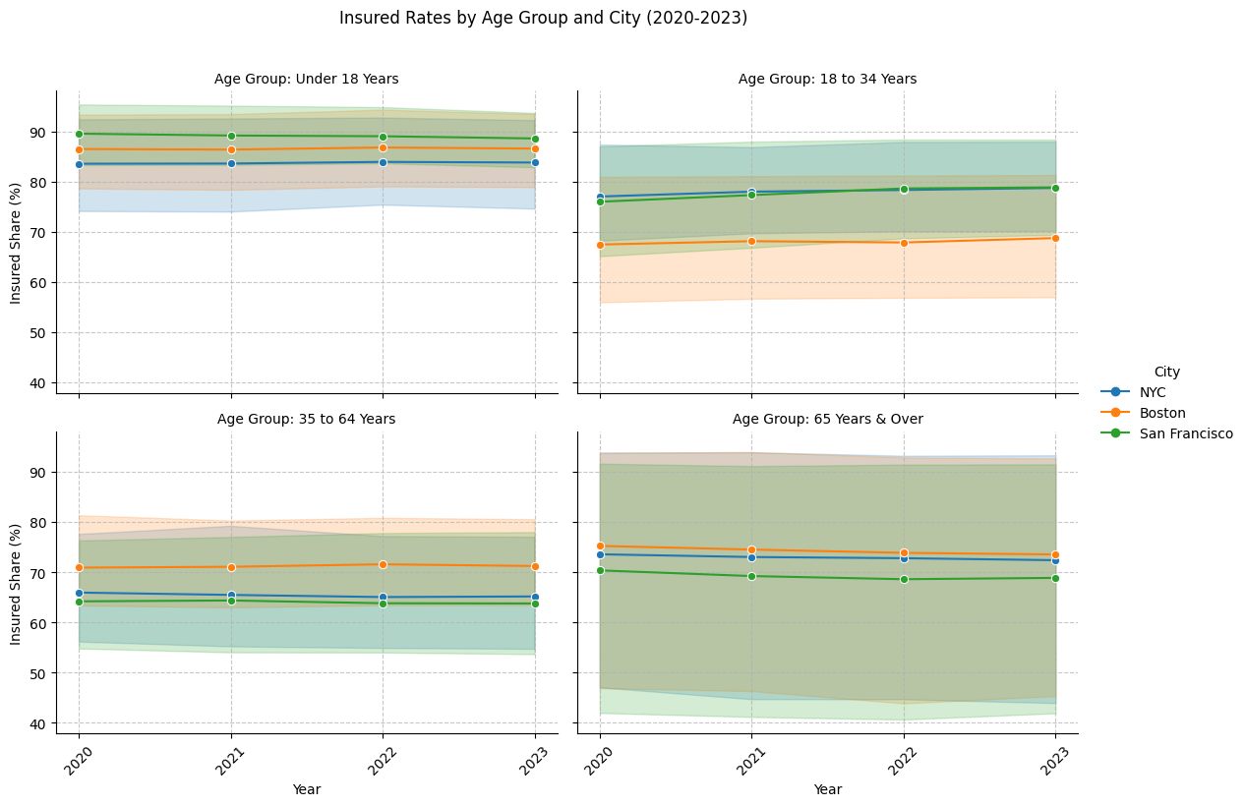We found that housing is most expensive in San Francisco, where the median home price is about $1.1 million, compared with roughly $657,000 in Boston and $635,000 in New York City. Median incomes are much lower than home values in all three cities, but the gap is widest in New York (about $82,000 vs. $635,000) and Boston (about $93,000 vs. $657,000). San Francisco’s much higher median income (around $145,000) helps narrow, but does not eliminate, the strain created by its exceptionally high housing costs.
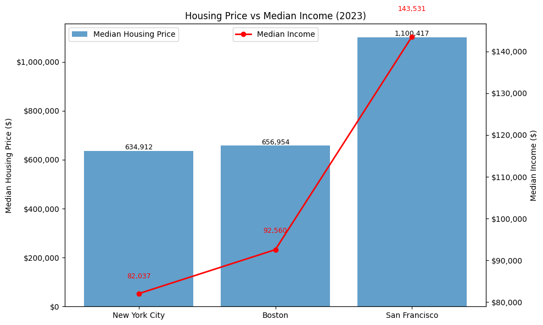

In terms of bachelor’s degree attainment among adults age 25 and over, San Francisco ranks highest, with 60.1% of residents holding a bachelor’s degree or higher. Boston follows at 49.7%, while New York City trails at 32.1%. These differences may reflect San Francisco’s concentration of tech firms that demand highly educated workers, as well as Boston’s dense cluster of universities and research institutions.
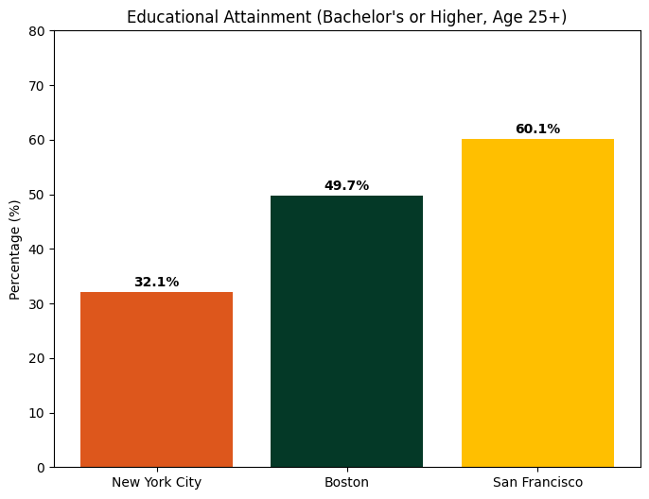

What We Learned During the Project Development

Working on this project helped us understand how much of data analysis depends on defining the right scope and finding usable data. In the beginning, we planned to compare many more cities and indicators, but once we started searching for datasets, it became obvious that our original idea wasn’t realistic. Narrowing the project down—after talking with the professor—made the work more focused and manageable, and it taught us how important it is to balance research goals with time and data availability.

A major lesson was that collecting and verifying data often takes more time than the actual analysis. Many datasets looked promising at first, but didn’t include the variables or level of detail we needed. We had to double-check sources, confirm definitions, and make sure that measures were comparable across cities. This process forced us to slow down, rethink our assumptions, and make sure we were building our analysis on solid ground.

On the technical side, we got much more comfortable using Python for real data work. We learned how to import and clean multiple datasets, inspect them carefully, merge them properly, and create new variables that allowed us to compare the three cities on equal terms. Repeatedly checking shapes, sample rows, and summary statistics helped us catch issues early and build more confidence in our code.

Finally, we learned a lot about collaboration. Each of us worked on a different indicator, but our pieces still had to connect into one coherent analysis. Sharing code, discussing problems, and helping each other troubleshoot taught us how to coordinate effectively during a multi-step technical project. Overall, the development process showed us how technical skills, planning, and teamwork all come together in real analytics projects.

Helpful Resources

- CIS 9650 Course Materials (Slides, Notebooks, and Code Examples)
The class notes and walkthroughs guided most of the data preparation and visualization work. The examples on file handling, Pandas, merging data, and plotting in Python were especially useful when we were cleaning and combining datasets for each city. The earlier lectures on Python basics also helped us avoid common errors and kept our code organized and readable.

- Public Data Platforms (Data USA, ACS, Kaiser, Zillow)
These sites provided the core datasets for our analysis. Their documentation pages helped us understand how variables were defined and whether different cities’ numbers could be directly compared.

- Google Colab + Google Drive
Using Colab made it easy for all of us to run the notebook and share datasets without needing to install anything locally. The class instructions on connecting Colab to Drive made it straightforward to keep all of our files in one place.

- Official Documentation for Pandas, NumPy, and Matplotlib
Whenever we got stuck—especially with merging, reshaping data, or formatting visualizations—the library documentation helped us figure out the correct methods and parameters.

- Team Collaboration
A lot of troubleshooting happened simply by talking through issues with each other. Reviewing each other’s code, sharing alternative approaches, and checking outputs together made the project more accurate and more manageable.

Reflection
Overall, this project allowed us to learn how to source datasets from open platforms, assess their reliability, and adjust our project scope based on dataset scale and the time available to complete the work. We applied concepts learned in class, supplemented by additional resources, to create visualizations that effectively present key information and provide a comprehensive answer to our research questions.
We also divided tasks among team members and used role rotation to ensure that everyone contributed to various components of the project and gained broader experience. Each member focused on a specific question during the coding process, and we collaborated closely by sharing feedback and discussing progress during our weekly meetings. This combination of individual effort and group coordination strengthened both the quality of our work and our overall learning experience.
If we were assigned a similar project in the future, we would begin by conducting an initial exploration of the datasets much earlier. We would also start searching for datasets only after clearly defining the specific time frame and variables required for our analysis.
While it is understandable to come up with research questions that are broad in scope, if we were to do the project again, we would spend more time upfront refining our research questions while simultaneously evaluating the accessibility, reliability, and alignment of the specific datasets needed to answer them.

MEETING NOTES
Team Meeting 1
Date | Sep 19, 2025
Time | 9:30 pm - 10:10 pm
Communication Method | Zoom
Attendees | Chris, Eleni, Paul, and Zhenfang
Agenda | - Fill out the team charter and assign each initial role  - Dataset decision: US Census Bureau  - Confirm communication and meeting schedule  - Set up a shared Google Drive folder and upload materials  - Assign the following steps
Key Discussion | See Team Charter
Action Steps | - Zhenfang will write up our first team meeting note.  - Eleni will set up a shared Google Drive Folder and upload materials.  - Everyone will brainstorm initial questions that can be researched/explored using the US Census Bureau dataset.
Agenda for Next Meeting | - Finalize Team Charter  - Propose at least 5 research questions based on this project  - Assign tasks for the proposal draft

Team Meeting 2
Date | Sep 26, 2025
Time | 7:45 pm - 8:30 pm
Communication Method | Zoom
Attendees | Chris, Eleni, Paul, and Zhenfang
Agenda | - Decide on the team name  - Brainstorm at least 5 questions together  - Review dataset options from the US census data  - Decide on a consistent meeting time (Fridays at 9 PM)
Key Discussions | Ideas/ Questions to answer on the project  - Educational attainment in rural/urban/suburban areas  - How does NYC’s quality of life compare to the other selected cities?  10 Selected Cities: NYC, Dallas, San Francisco, Phoenix, Boston, D.C., Los Angeles, Seattle, Miami, Chicago  - How does the attainment of higher education compare between different US cities?  - Can we do a graduation rate comparison?  - How does the rate of having health insurance compare among the 5 boroughs in NYC?  - What other metrics can we use to determine which borough has the healthiest number of residents?  - Comparison of the affordability of NYC to other metro cities in the US  - Is NYC getting more expensive in comparison to other US cities?  - How does the immigration data of NYC compare to other US cities?  - How does NYC’s dating scene compare to other US cities?  - This NYT article lists the best and worst cities for singles. Using US census data, we can extrapolate similar demographic/socio-economic data from “the best cities for singles” and compare them to “the worst cities for singles" in the US. We could also utilize that information to gain a better understanding of the NYC dating scene.  Role rotation  - To ensure everyone develops their technical skills and their leadership proficiency, our team will utilize a role rotation system. Using this system allows every member to have different exposure to the various aspects of this project. To manage the project efficiently, we would be utilizing a shared Google Doc that lists each team member’s role for the week and any other tasks to be completed by the group or by each team member, as well as any deadlines or requirements for each step of the project.
Action Steps | N/A
Agenda for Next Meeting | - Finalize the questions  - Download a dataset sample  - Begin exploring the variables needed for the questions

Team Meeting 3
Date | Oct 3, 2025
Time | 9:00 pm - 9:40 pm
Communication Method | Zoom
Attendees | Chris, Eleni, Zhenfang  Paul was unable to attend this meeting due to a family emergency. He notified us beforehand and shared his project idea notes via email for the team to reference during the discussion.
Agenda | - Finalize the questions
Key Discussion | Finalizing our initial questions  Questions need to point to a central theme - to depict a concise and coherent storyline.  Starting Question:  - How does NYC’s quality of life compare to the other selected cities?  10 Selected Cities: NYC, Dallas, San Francisco, Phoenix, Boston, D.C., Los Angeles, Seattle, Miami, Chicago.  Quality of life metrics for the project:  - Education  - Health  - Income vs home prices  - Access to Recreation - # of community centers, parks, libraries  - Commute time  Final Questions  - How does the attainment of higher education compare between the different US cities?  - How does the graduation rate compare between the different cities?  - How does the average commute time compare between NYC and the different cities?  - How does the number of residents with health insurance compare between NYC and the selected cities?  - How do the median income and house prices (mortgage and rental) compare between NYC and the selected cities?  - How does access to recreation(# of community centers, parks, libraries, museums, etc) compare between NYC and the selected cities?
Action Steps | - Zhenfang will write up the description of the data.  - Eleni will edit and proofread the project proposal and submit it.
Agenda for Next Meeting | - Download a dataset sample  - Begin exploring the variables needed for the questions

Team Meeting #4
Date | Oct 7,2025
Time | 9:30 am - 10:10 am
Communication Method | Zoom
Attendees | Chris, Eleni, Paul, Zhenfang
Agenda | - Change of datasets used for the project
Key Discussion | - Got Paul up to date on what he missed during Team Meeting #2.  - Discussed the game plan to address the Professor's announcement affecting our project  - The logistics surrounding our current situation and pivoting our focus completely, as well as the framework of a game plan to restructure our approach, given this new project focus.  - New data means we have to decide on a new team name, as we are not primarily using census data anymore.  - Finalize the project proposal and agree on what ‘done’ looks like in our current situation to deliver an MVP that we can then build upon. → We want to ensure a solid foundation before we continue to structure and design our project.  - Having 10 cities to work on could result in having a lot of data to sort through in the short time we have. → thoughts about reducing; concerns about the scope of the project and the consistency of the dataset we would find in the different city databases.  - (With the little time we had left, given the abrupt shift in sufficient dataset criteria, we plan to use the additional time we have before the final project progress report is due to buffer.)
Action Steps | - Looking through each city's open data sources, and finding specific datasets we can use for our project by splitting up the 10 cities amongst group members, so that we can be productive and efficient during the next meeting and going into it (especially because of the large amount of work we have ahead).  - Chris: Seattle, Miami, Chicago  - Paul: Boston, DC, LA  - Eleni: SF, Phoenix  - Zhenfang: NYC, Dallas
Agenda for Next Meeting (#5) | - Download a dataset sample and explore the variables needed to adequately answer the questions we currently have.

Team Meeting #5
Date | Oct 17,2025
Time | 9:20 pm - 10:05 pm
Communication Method | Zoom
Attendees | Chris, Eleni, Zhenfang, Paolo
Agenda | - Review Professor's feedback  - Confirm the final cities for comparison with NYC  - Review data availability from each city’s Open Dataset
Key Discussion | Final Cities: NYC, Boston, San Francisco  - SF database based on Survey data, got data from the Census Bureau, but used it to create its own census for itself
Action Steps | - Paolo will write an email to Prof to confirm the proposal’s feedback and final metrics lists
Agenda for Next Meeting | - Confirm final research questions and metrics for analysis.  - Review and compare datasets from NYC, Boston, and San Francisco.

Team Meeting # 6
Date | Oct 24,2025
Time | 9:00 pm - 9:45 pm
Communication Method | Zoom
Attendees | Chris, Eleni, Zhenfang, Paolo
Agenda | - Recap professor’s feedback - Shift from 10-city comparisons to NYC, San Francisco, and Boston  - Discuss how to move towards initial data exploration
Key Discussion | Tasks to do: Data exploration  - Compare the datasets we currently have: NYC data vs San Francisco, NYC data vs Boston data  - Check alignment in terms of years, other metrics, and if they don’t align, present to the group → search for more viable datasets  - Compare the datasets we currently have with our initial questions  - Verify if we require additional datasets to address our initial questions. If not, develop a different strategy or consider more compatible datasets.
Action Steps | - Share sheet for datasets fields  - Comparing datasets for NYC vs Boston - Chris  - Comparing datasets NYC vs San Fransico - Paolo  - Comparing all datasets to questions #1 - #3 Zhenfang  - Comparing all datasets to questions #4- #6 Eleni
Agenda for Next Meeting | Come up with a strategy after initial data exploration

Team Meeting #7
Date | Nov 7, 2025
Time | 9:00 pm - 9:45 pm
Communication Method | Zoom
Attendees | Chris, Eleni, Zhenfang, Paolo
Agenda | - Recap the last meeting’s progress.  - Finalize dateset
Key Discussion | - Identified viable data sources for NYC, Boston, and San Francisco  - dataUSA.io  - Zillow housing/rental prices  - Discussed the feasibility of five metrics (education, health insurance, commute time, and income vs housing).  - Decided to remove our 6th question
Action Steps | Each member summarized findings for the assigned metric:  Chris: Health coverage insurance  Eleni: Average commute time  Paolo: Higher education attainment, graduation rate  Zhenfang: Median income vs housing
Agenda for Next Meeting | - Compare chosen city data  - Draft visualizations

Team Meeting # 8
Date | Nov 16, 2025
Time | 10:00 am - 10:45 am
Communication Method | Zoom
Attendees | Chris, Eleni, Zhenfang, Paolo
Agenda | Data analysis and exploration tasks  Progress Report Submission  - Update to research questions and data sources  - Preliminary findings  - Roles and next steps
Key Discussion | - Created a folder for each question in our shared Google Drive. Each team member will work on the datasets and a Jupyter file of the question they are working on in the file.  - Everyone will submit their own data exploration analytics by sharing them on our shared Google Drive folder under the Progress Report by Tuesday, November 18th, 12:00 pm.  - Paul sends edited summaries of all individual data analyses to Eleni by Tuesday, 11:59 PM  - Role switch between Paul and Zhenfang
Action Steps | Progress Report to do list  - Findings from exploratory data analysis - all team members  - Summary of all individualized analyses - Paolo  - Changes to the questions initially planned to answer for the project, completed tasks, and remaining tasks- Eleni  - Meeting notes to date - Zhenfang
Agenda for Next Meeting | - Update on data analysis and setting milestones, and deadlines  - Discuss current roles and make adjustments if necessary

Team Meeting # 9
Date | Dec 1, 2025
Time | 8:35 am - 9:15 am
Communication Method | Zoom
Attendees | Chris, Eleni, Zhenfang, Paolo
Agenda | - Discussing project deadlines and requirements  - Specific plan with internal deadlines for certain milestones(Ex, code completion)  - Discussing the project progress for each research question (looking over team members’ Jupyter code)
Key Discussion | - Specific plan with internal deadlines  - By next Saturday, 11:59 PM, all team members will finish the project code and share it in the group’s shared folder  - At our Meeting on Sunday, we will all merge our Jupyter notebooks. We also discussed the importance of not losing any important code while merging notebooks and debugging.  - Sunday-Wednesday, we finalize and submit the final report and PPT slides  - Briefly discussed the timing of the presentation and decided that we will all be presenting the questions we assigned ourselves during the final presentation. All team members will present.  - Reminder about completing the peer review individually and submitting before the deadline on 12/10.  - Discussing the project progress for each research question  - Zhenfang’s income vs. housing code visualizations — the group gave recommendations for enhanced readability.  - Paul will attempt to add a Pie chart to his education visualizations if possible to diversify the visualization method.  - Chris’ Health Insurance EDA — made suggestions to enhance it and include more data visually. He’ll also attempt to incorporate a box plot into his visualizations if possible.  - Eleni will incorporate more dynamic visualizations for commute time comparison.
Action Steps | Completing an individual’s Jupiter code by Saturday,12/ 06 midnight
Agenda for Next Meeting | - Merging Jupiter notebooks  - Task assignment regarding the final presentation and report.

Team Meeting #10
Date | Dec 6, 2025
Time | 10:10 am - 11:40 am
Communication Method | Zoom
Attendees | Chris, Eleni, Paolo, Zhenfang
Agenda | - Merging each team member’s Jupyter notebook  - Task assignment regarding final reports and presentation.
Key Discussion | - Merging each team member’s Jupyter notebook  - Eleni, Chris, and Zhenfang merged their codes into a shared Jupyter notebook on Colab  - Paul will merge his code right after the meeting and will let us know if any problem arises.  - Task assignment regarding final reports and presentation  - Presentation  - Zhenfang prepared a presentation slide and shared it with us earlier in the week. The group will continue to use that and will upload their own slides for their parts.  - Eleni will present the introduction, and Chris will present the conclusion.  - Final Report  - Each team member will be responsible for a part of the final report. Individual parts will be submitted to the project manager (Eleni) by Tuesday, 06/09 at 8:00 pm  - Zhenfang: Introduction and challenges during the project development  - Paul: What we learned during project development and helpful resources  - Chris: Description of data preparation and answer to initial questions.  - Eleni: Reflection/What to do differently next time, and final proofreading and editing
Action Steps | - Paul will complete merging his project code ASAP.  - Each team member will submit their individual parts of the final report by Tuesday, 8:00 pm.  - Eleni will submit the deliverables after doing a final check.  - Each team member will edit and modify their slides and prepare for the presentation.  - Each team member will submit the peer evaluation by Wednesday am.
Agenda for Next Meeting | N/A

